**Hands-on-Labs set up**

The series of hands-on labs are designed to teach you how to build applications using Application Express. The primary vehicle for teaching is a single-use case which is expanded on with each lab.

To run these hands-on-labs, you need to:

Obtain an Oracle Application Express Workspace and a Workspace Administrator /Developer user account. Select the most appropriate option from those listed below to obtain a Workspace:

**Oracle Cloud Free Tier** – <https://apex.oracle.com/en/> -Sign up for Always Free Oracle Cloud, provision an Autonomous Database, and create an APEX workspace.

**Oracle Database 18c Express Edition** - Download Oracle XE and install on your laptop or desktop machine and then download and install the latest Oracle Application Express release.

[**Download and run a preconfigured VM**](https://www.oracle.com/database/technologies/databaseappdev-vm.html)**-** Run APEX in a preconfigured Oracle VM VirtualBox using Database Application Development Virtual Appliance. A single download gives developers a free VM with Oracle Database, Oracle REST Data Services, and APEX ready to run.

**Option 1: Setting up Oracle Application Express (APEX) Account**

The Oracle APEX Application Development service provides a preconfigured, fully managed, and secured environment in Oracle Cloud to build and deploy world-class applications.

Go to the APEX web page

<https://apex.oracle.com/en/>

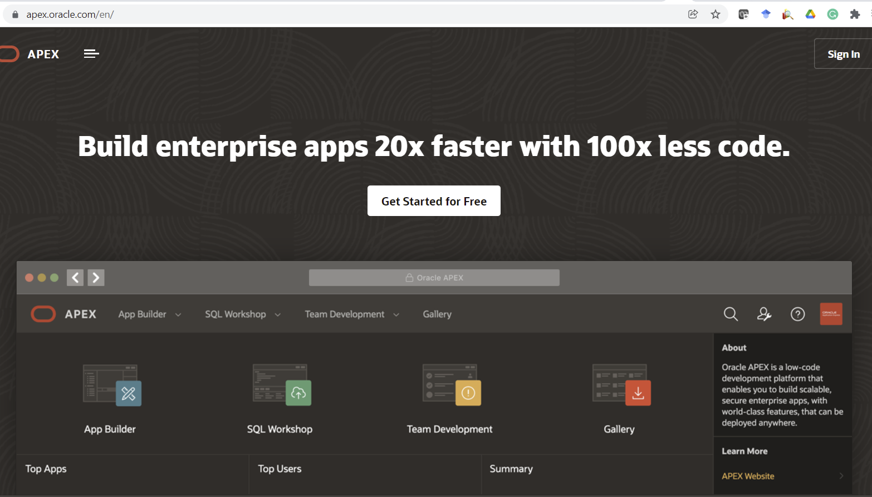

**Request a free APEX workspace using Oracle cloud**

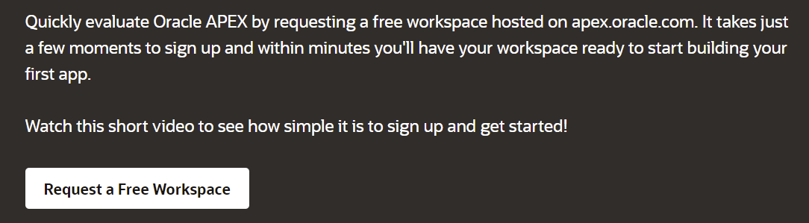

The Oracle APEX Application Development service provides a preconfigured, fully managed, and secured environment in Oracle Cloud to build and deploy world-class applications.

Click on request a free workspace: <https://apex.oracle.com/pls/apex/f?p=4700:2:21250271478590>:::::

Fill in the below form and you will get instant email

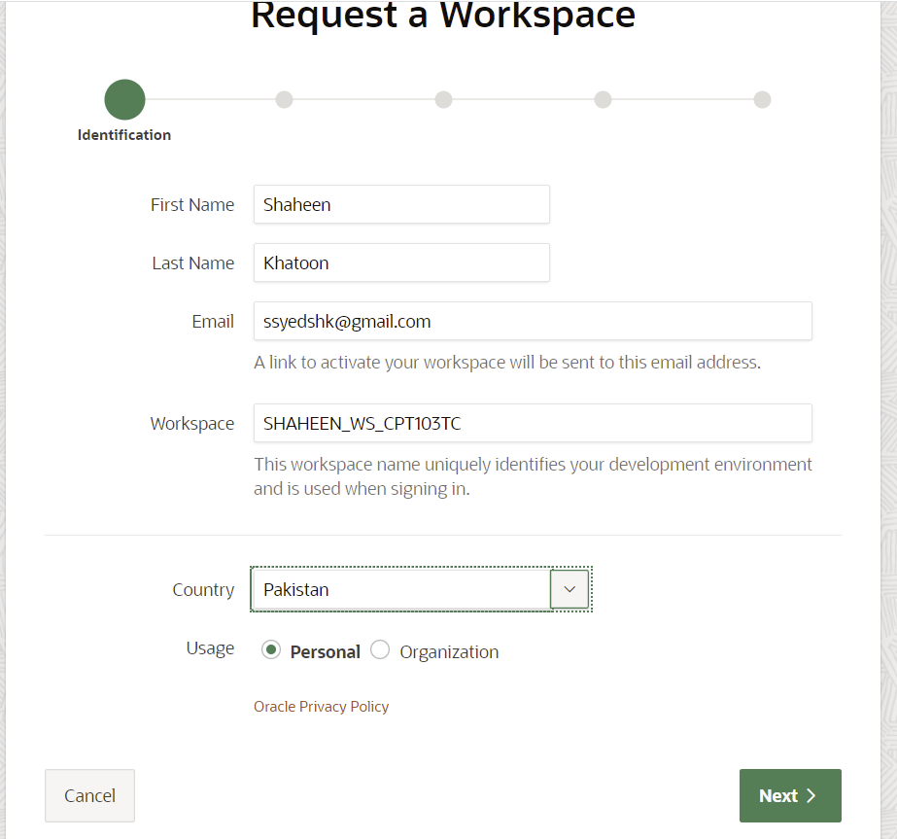

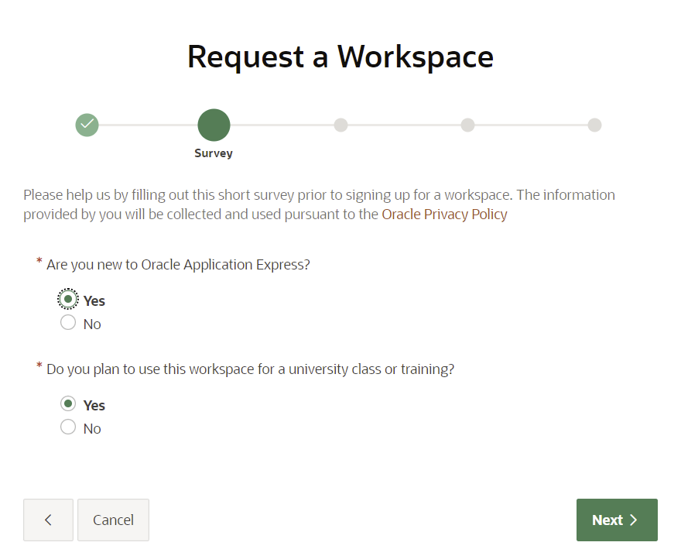

You will receive an instant email as below:

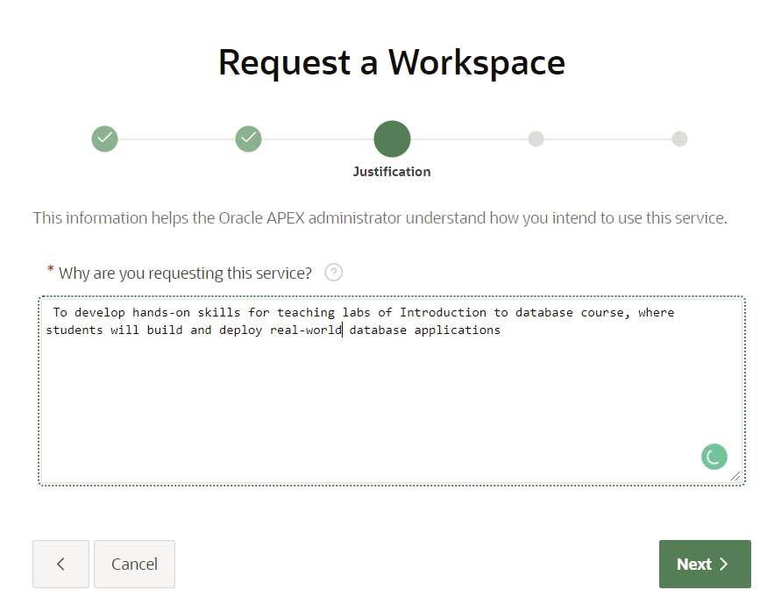

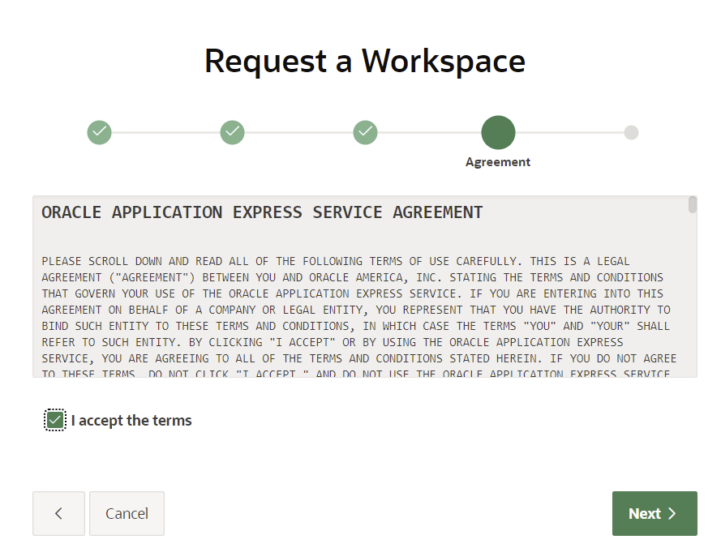

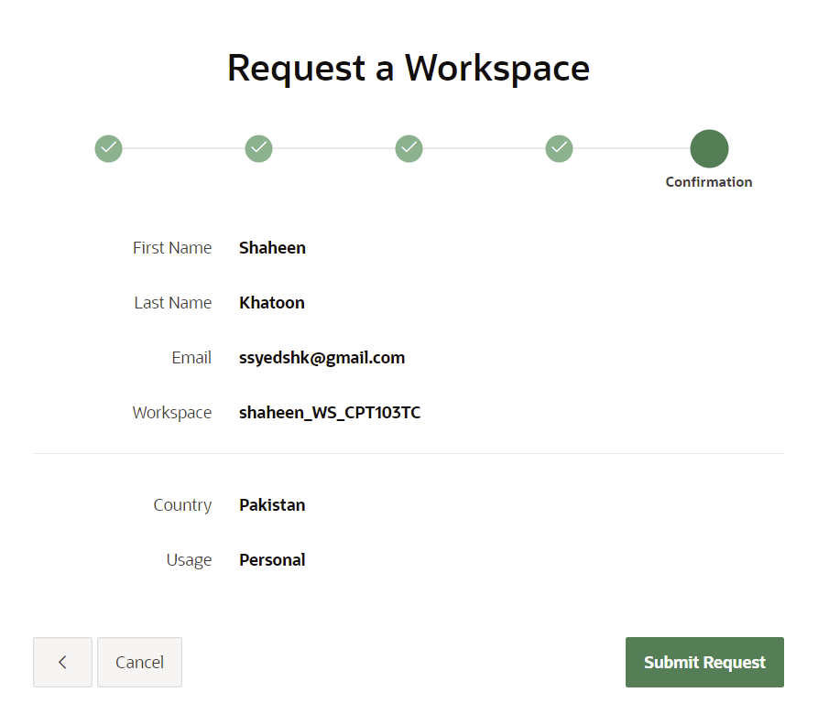

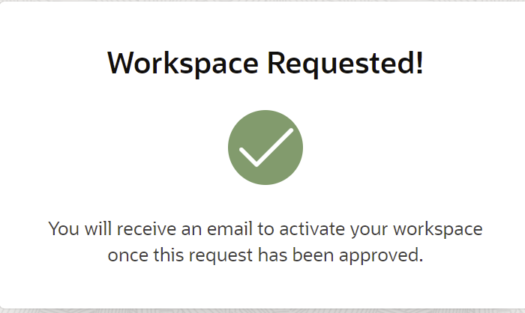

Check you email and click on Create Workspace

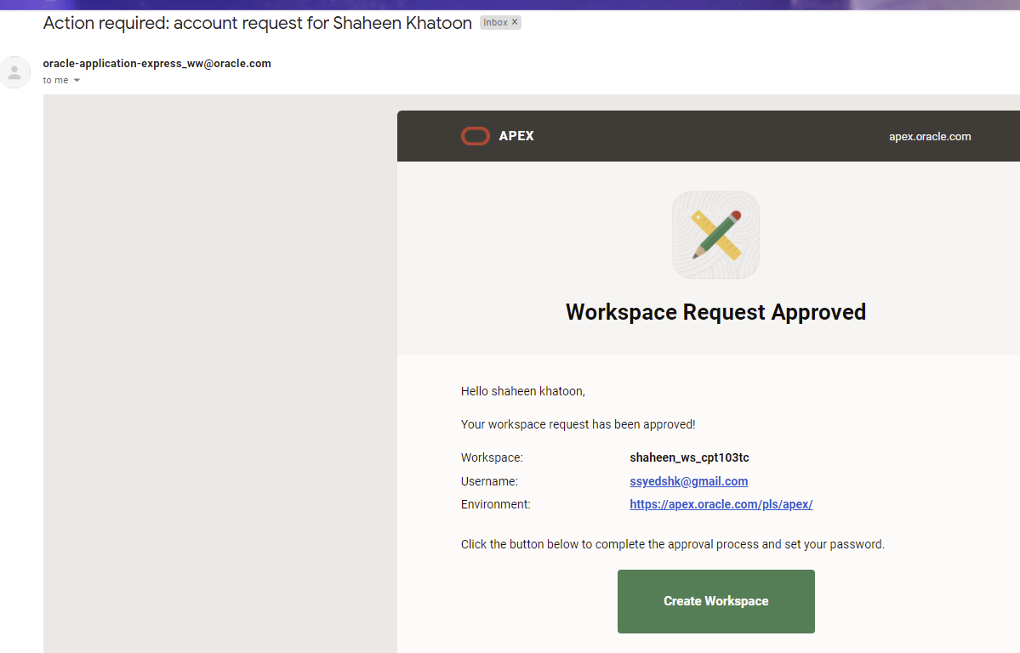

Note down workspace and username for later login and click on Create Workspace.

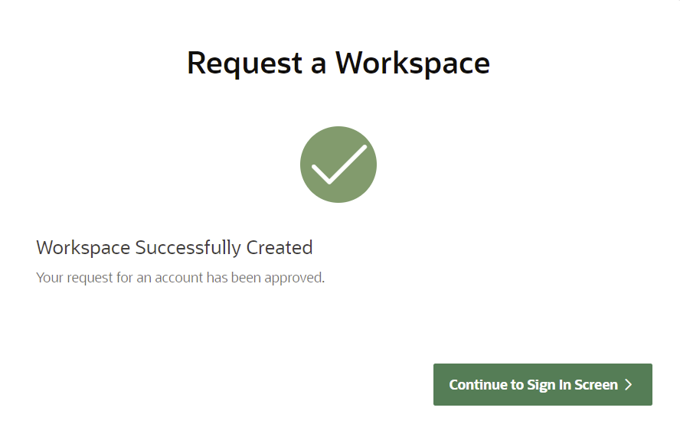

Click on Continue to Sign In Screen and set your first time password, then click on Change Password.

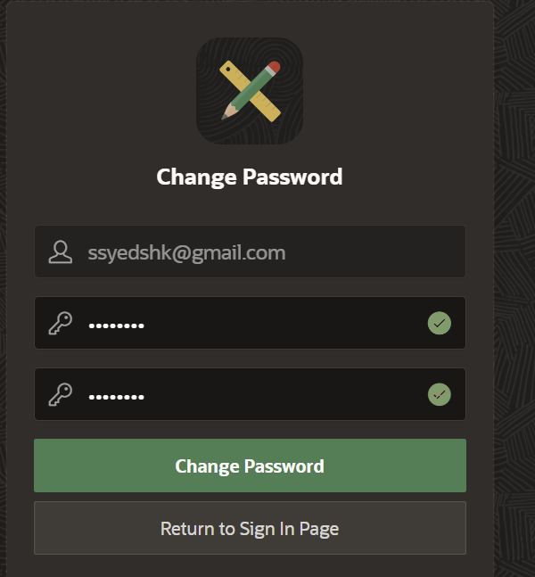

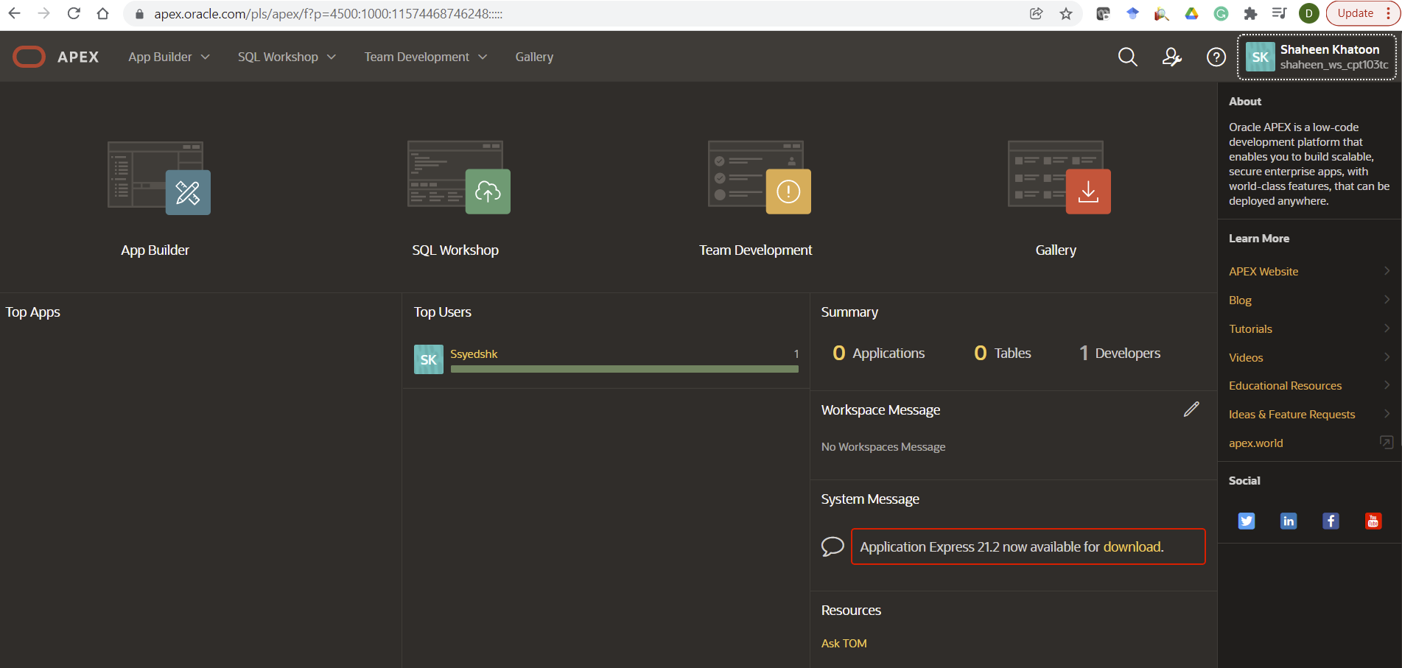

Congratulations! Apex is now ready to use.

**Next time login**: go to the below URL:

<https://apex.oracle.com/en/>

click on Sign in

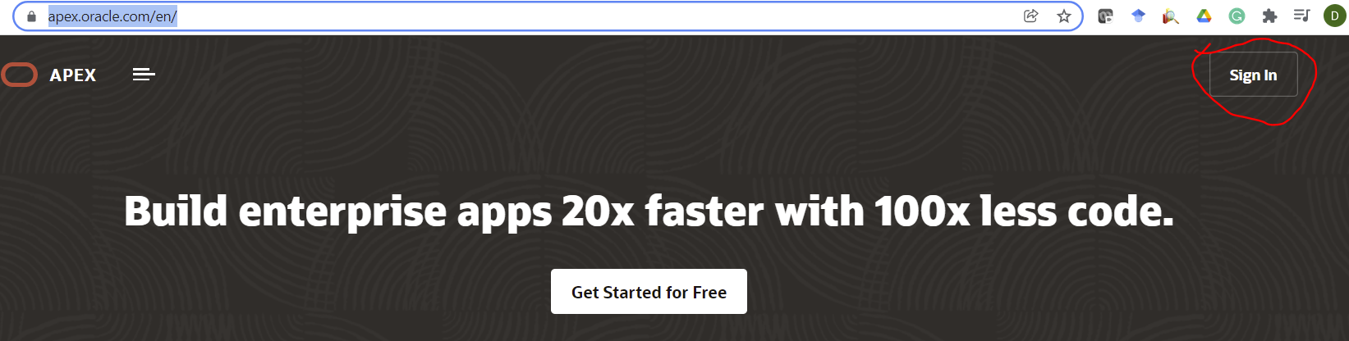

Provide the following to open the APEX workspace

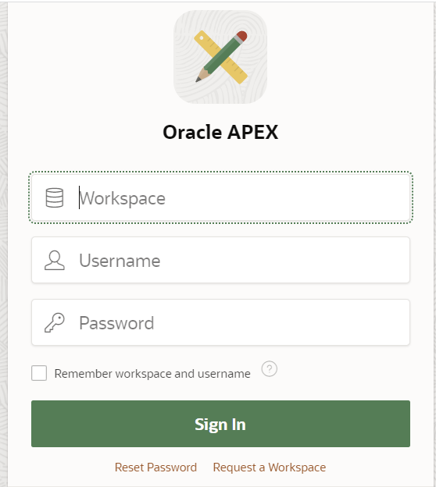

**Option 2: download and install Oracle APEX locally**

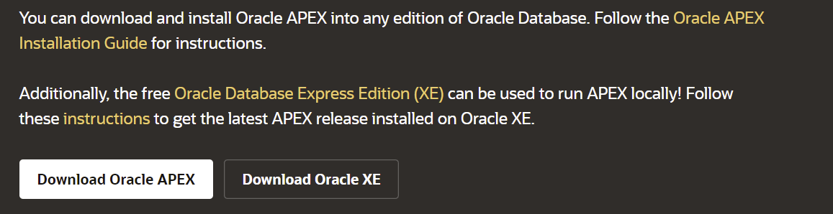

**If you want to download APEX on your local machine, please follow the**[**Oracle APEX Installation Guide**](https://www.oracle.com/pls/topic/lookup?ctx=en/database/oracle/application-express/21.1&id=HTMIG-GUID-DB8E4B2B-1AEB-4B76-BBA3-31C5876C3F14)**for instructions.**

**Option 3:** [**Download and run a preconfigured VM**](https://www.oracle.com/database/technologies/databaseappdev-vm.html)

Run APEX in a preconfigured Oracle VM VirtualBox using Database Application Development Virtual Appliance. A single download gives developers a free VM with Oracle Database, Oracle REST Data Services, and APEX ready to run.

Please follow instructions to set up the VM environment from the below link:

<https://www.oracle.com/database/technologies/databaseappdev-vm.html>